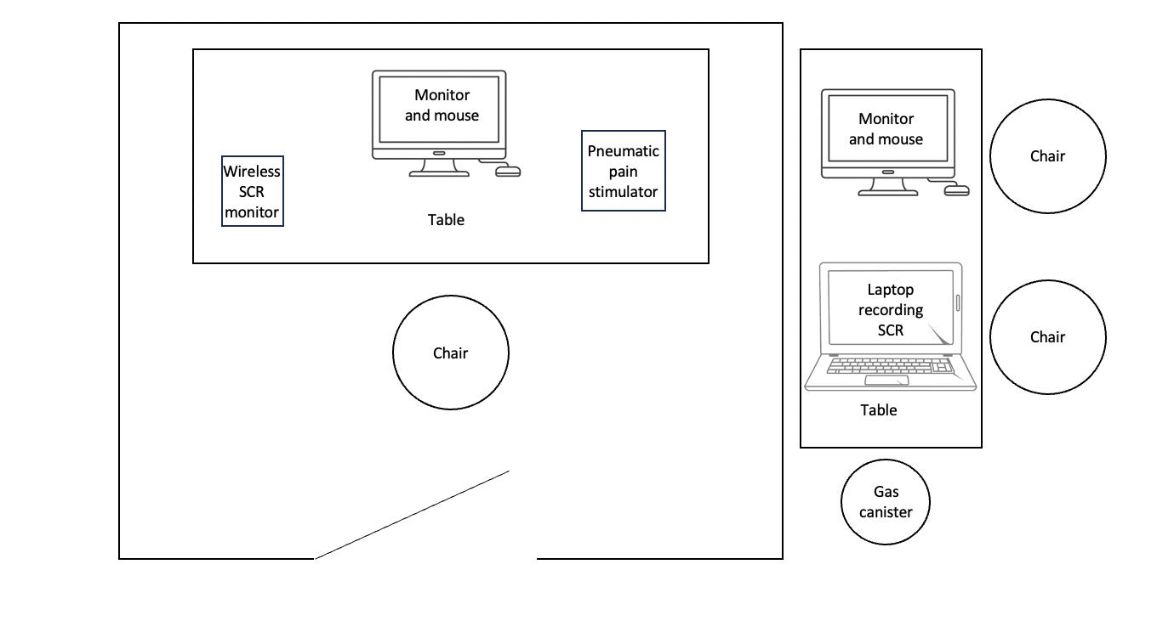

S1 Fig. Diagram representing the layout of the experimental setup in the laboratory.

