**Figure S2**. **Associations of PCL-R Facets and gray mater volume, and emotional recognition performance**

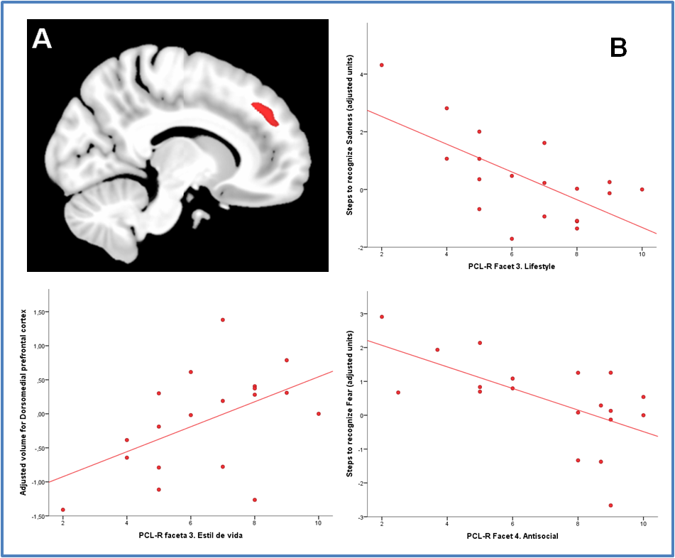

Significant associations between PCL-R Facets and (A) dorsomedial prefrontal cortex volume and (B) task performance in psychopaths. The plot displays residual variables once covariates were controlled for.